Fwd: Process management - Assignment

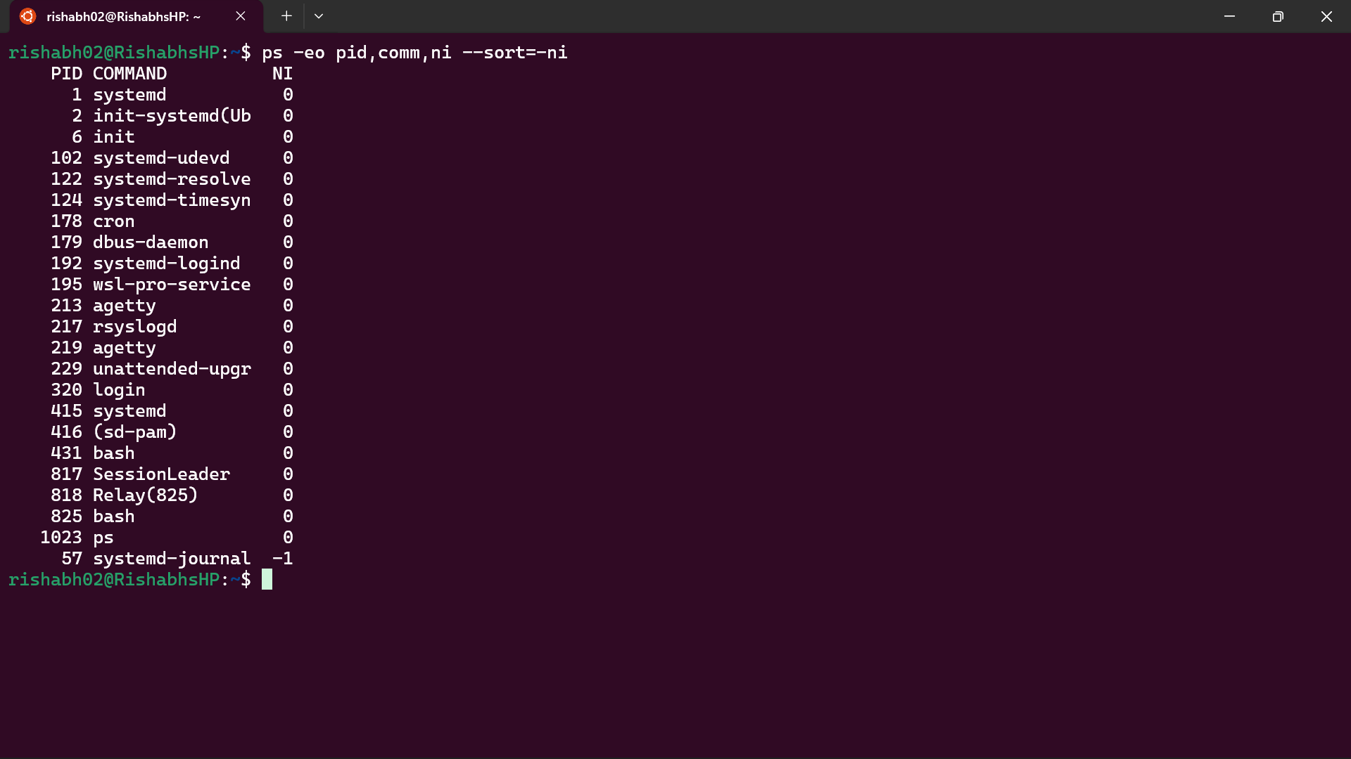
1) List out highest priority process in the system

2) Open terminal with 2 tabs or sessions
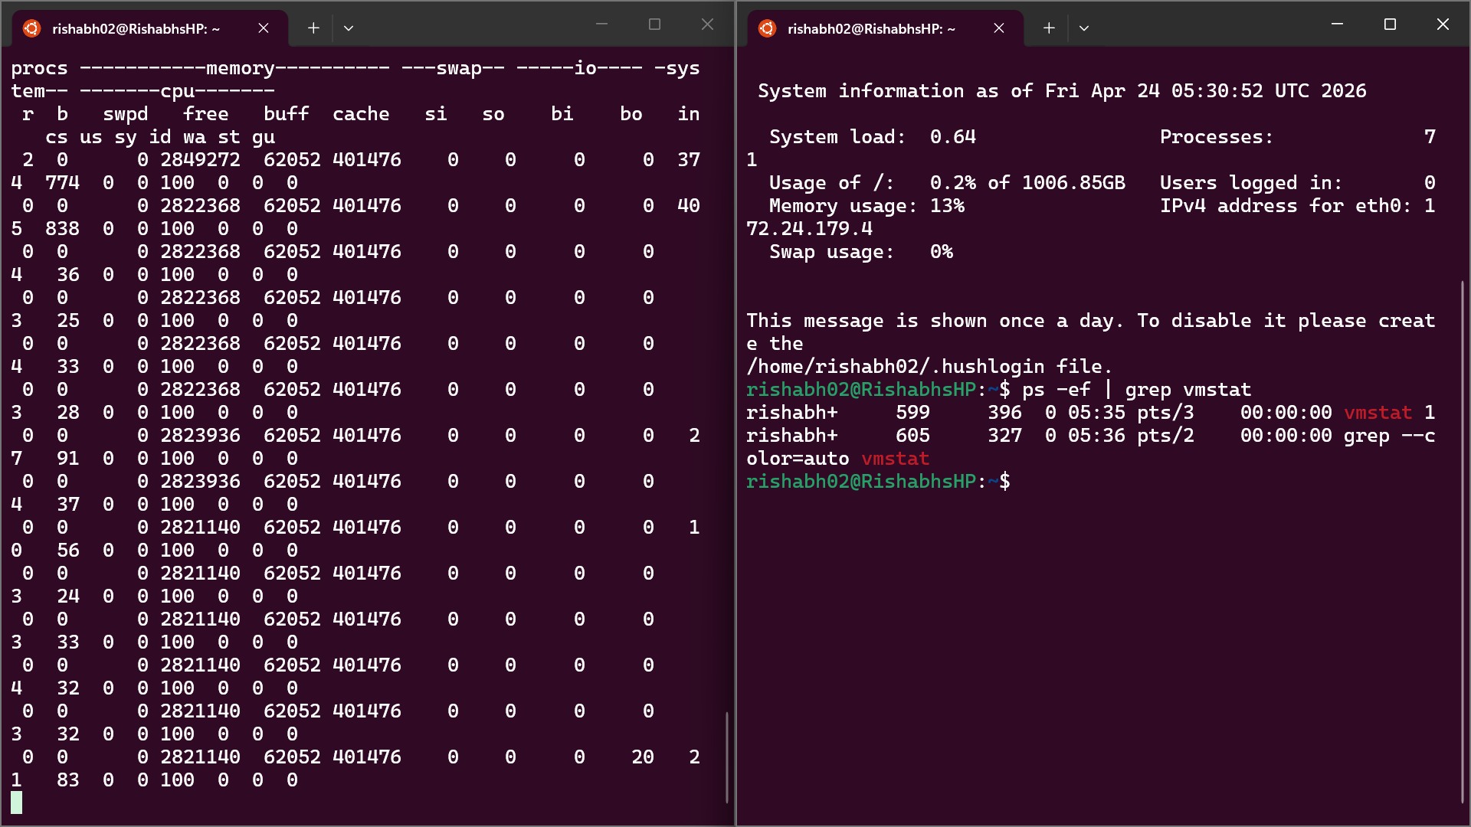
a) run command "vmstat 1"

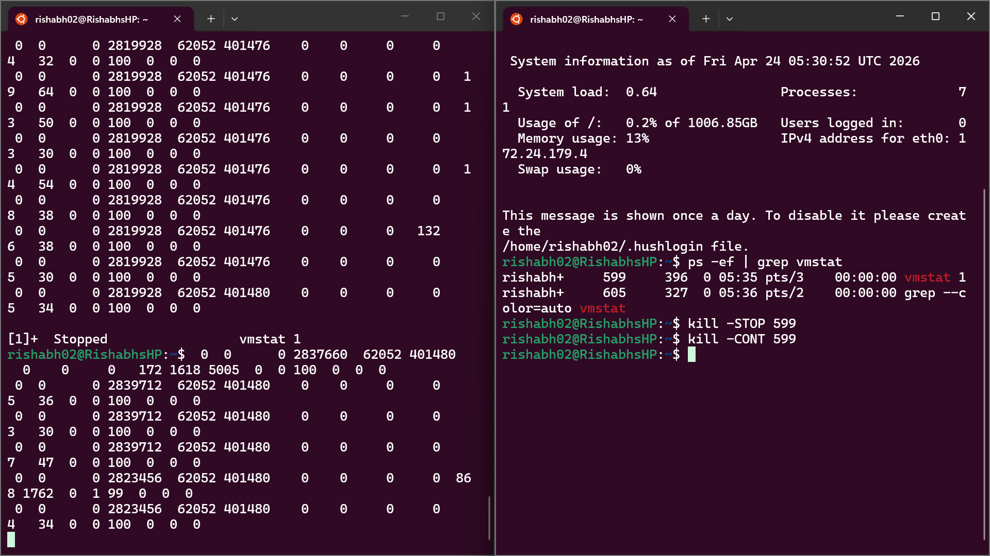
b) switch to another tab, pause running vmstat command for few seconds and resume it again

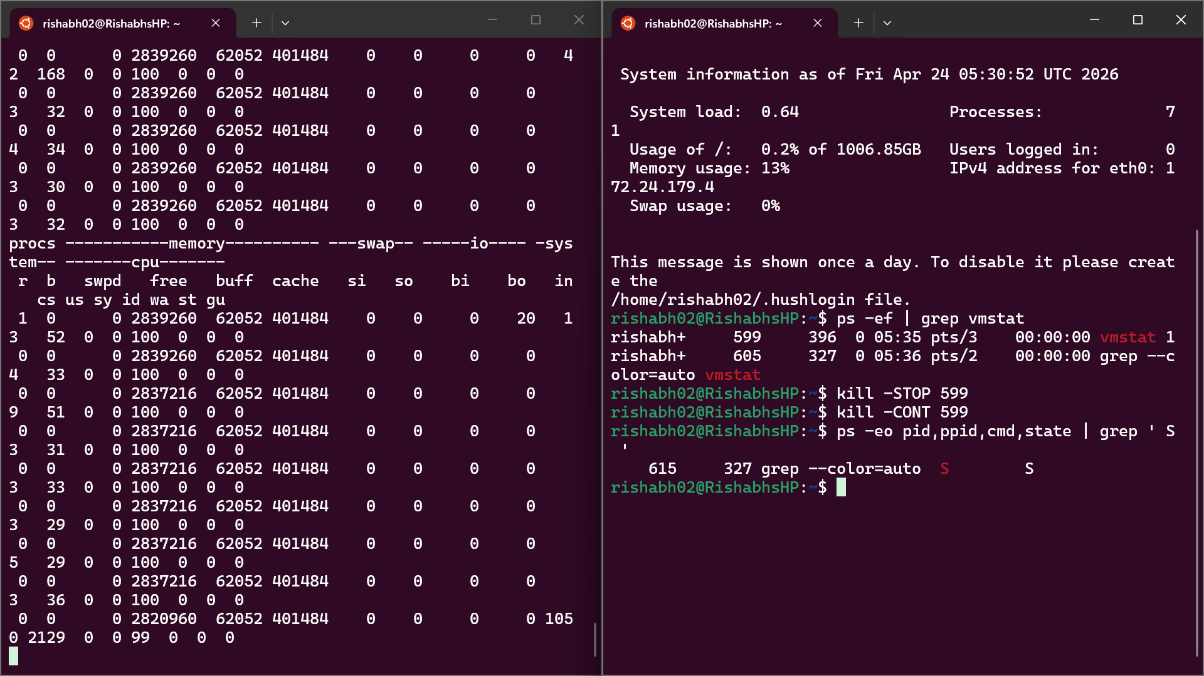
3) Find the process which is sleeping in "wait" state.

Explanation :-

1) List out highest priority process in the system
Command:
ps -eo pid,comm,pri,ni --sort=pri | head -n 5
Explanation:
- ps -eo displays all running processes
- pid is process ID
- comm is command name
- pri is priority
- ni is nice value
- --sort=pri sorts processes by priority in ascending order
- head -n 5 shows top 5 processes
Important:
Lower priority value means higher priority.
The first process in the output is the highest priority process.

2) Pause and Resume a Running Process using Signals
Step 1: Open two terminal sessions
Step 2: In terminal 1 run:
vmstat 1
Explanation:
This command shows system performance every 1 second continuously.
Step 3: In terminal 2 find the process ID:
ps -ef | grep vmstat
Step 4: Pause the process:
kill -STOP <PID>
Explanation:
SIGSTOP signal pauses the process execution.
Step 5: Resume the process:
kill -CONT <PID>
Explanation:
SIGCONT signal resumes the paused process.

3) Find process in wait (sleeping) state
Command:
ps -eo pid,comm,state | grep S
Alternative:
ps -eo pid,comm,state | grep '^.*[SD]'
Explanation:
Process states:
R = Running
S = Sleeping (waiting for event)
D = Uninterruptible sleep (waiting for I/O)
T = Stopped
Z = Zombie
Sleeping state means the process is waiting for an event like input or signal.
Blocking state (D) means the process is waiting for I/O operations.

